**Group Members:**

|  |  |  |
| --- | --- | --- |
| **SR. No.** | **Name** | **Enrollment** |
| 01 | Mahnoor Muzaffar | 02-131222-021 |
| 02 | Humna Ahmed | 02-131222-034 |
| 03 | Sarah Qasim | 02-131222-069 |
| 04 | Hajra Imran | 02-131222-091 |

**Smart Home Automation System**

**Question:** Develop project definition, vision statement, FR & NFR, 4 Uml diagrams, 2 low fidelity, and 2 high fidelity prototypes of the given scenario in the session slides.

**Project Definition:**

The Smart Home Automation System aims to solve the issue of fragmented control over smart home devices. Currently, users face difficulty in managing various devices from multiple apps. This project proposes a centralized mobile application that allows users to seamlessly control and monitor lights, thermostats, and other essential smart devices from a single interface.  
The application will provide an intuitive UI, ensure secure access, and support scalability for future integrations. The goal is to increase user convenience, reduce energy consumption, and enhance home security.

**Vision Statement:**

**For** homeowners **who** struggle to manage multiple smart devices through different apps**, the** Smart Home Automation System **is a** mobile application **that** centralizes control over various smart home devices with an intuitive, user-friendly interface. **Unlike** existing fragmented solutions, **our product** offers unified device management, improved user experience, and scalability for future smart integrations.

**Functional Requirements:**

1. The system must allow users to log in securely.
2. Users should be able to turn lights on/off from the mobile app.
3. Users should be able to control thermostat temperature settings.
4. The system must allow users to view the current status of connected devices.
5. Users should be able to add/remove devices.
6. The app must send notifications for device alerts (e.g., temperature too high).

**Non-Functional Requirements:**

1. The app should load within 2 seconds on standard mobile devices.
2. The system should support up to 100 connected devices per user.
3. All communication must be encrypted (e.g., using SSL).
4. The system should be available 99.9% of the time (high availability).
5. UI must be responsive and work on both Android and iOS platforms.

**Uml diagrams:**

**1. Use Case Diagram**

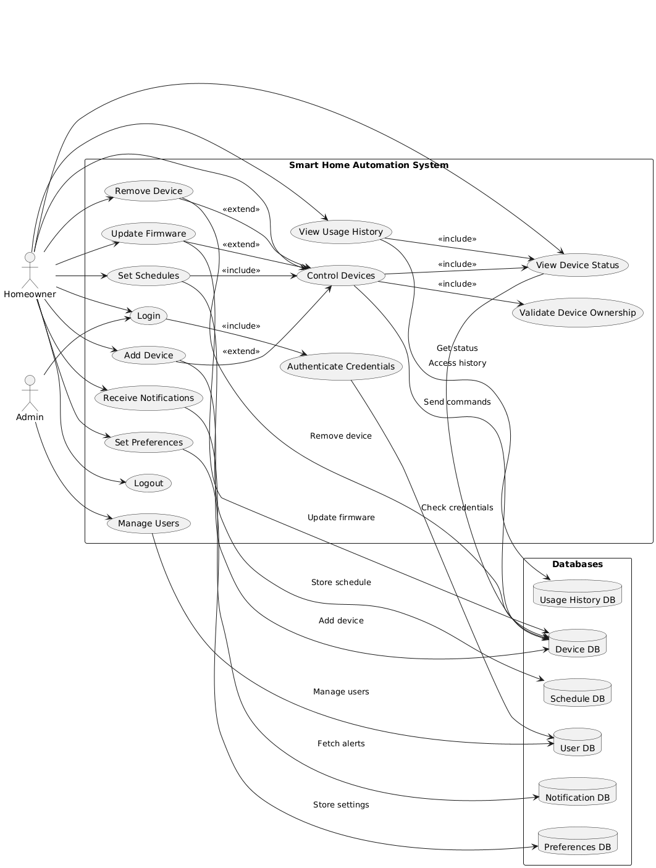

**2. Class Diagram**

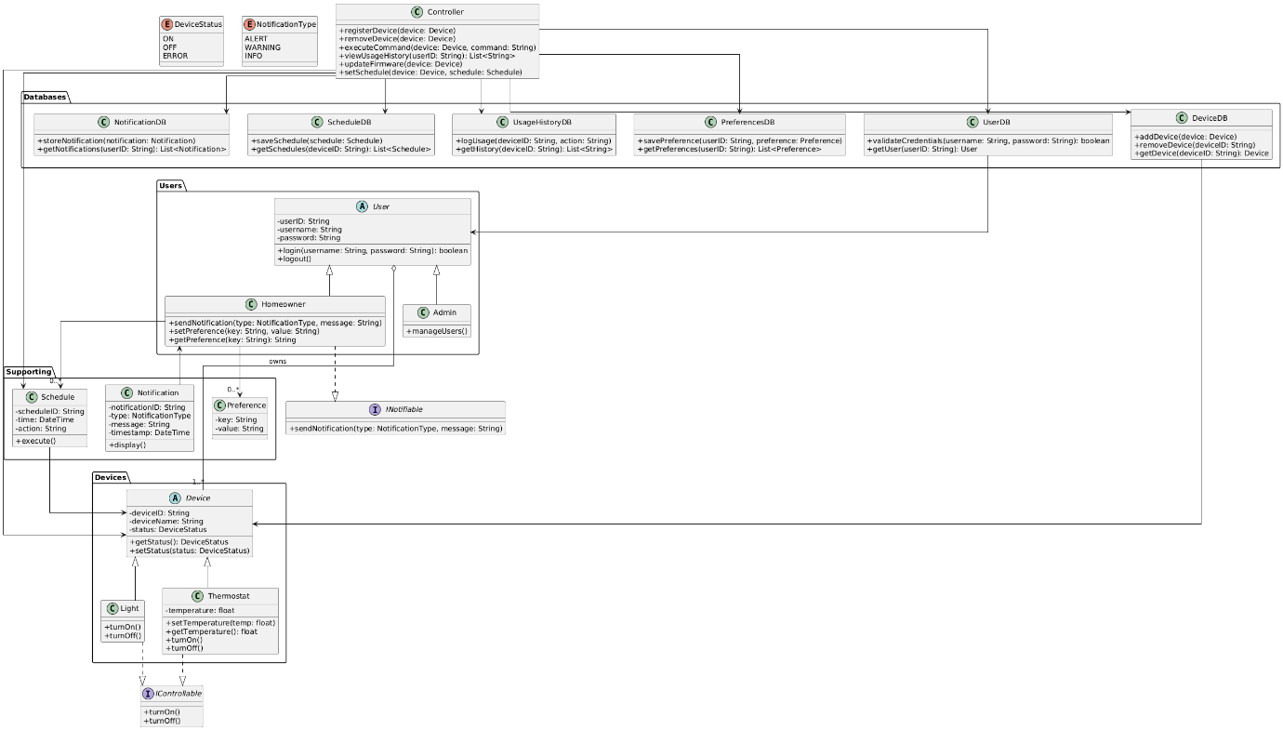

**3. DFD Level 0 – Diagram:**

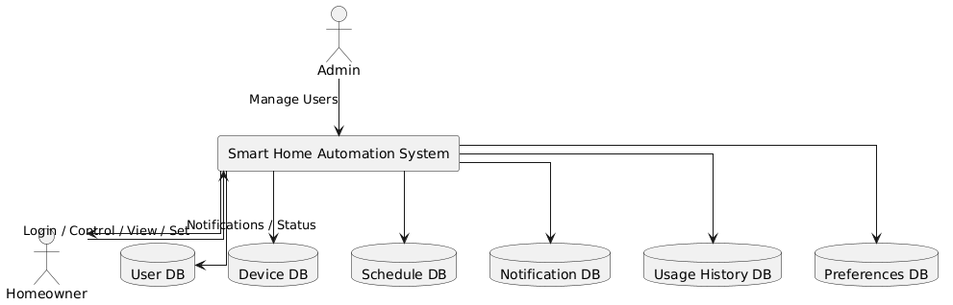

**DFD Level 1 – Diagram:**

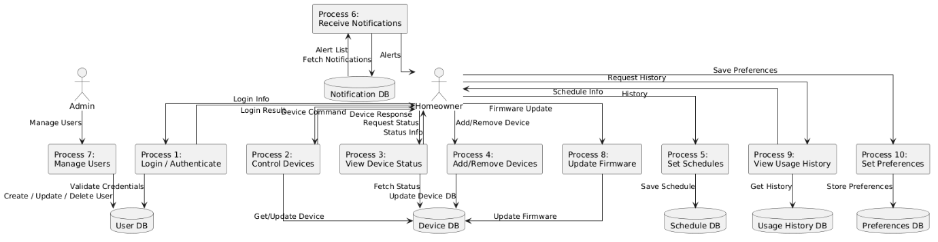

**4. Sequence Diagram**

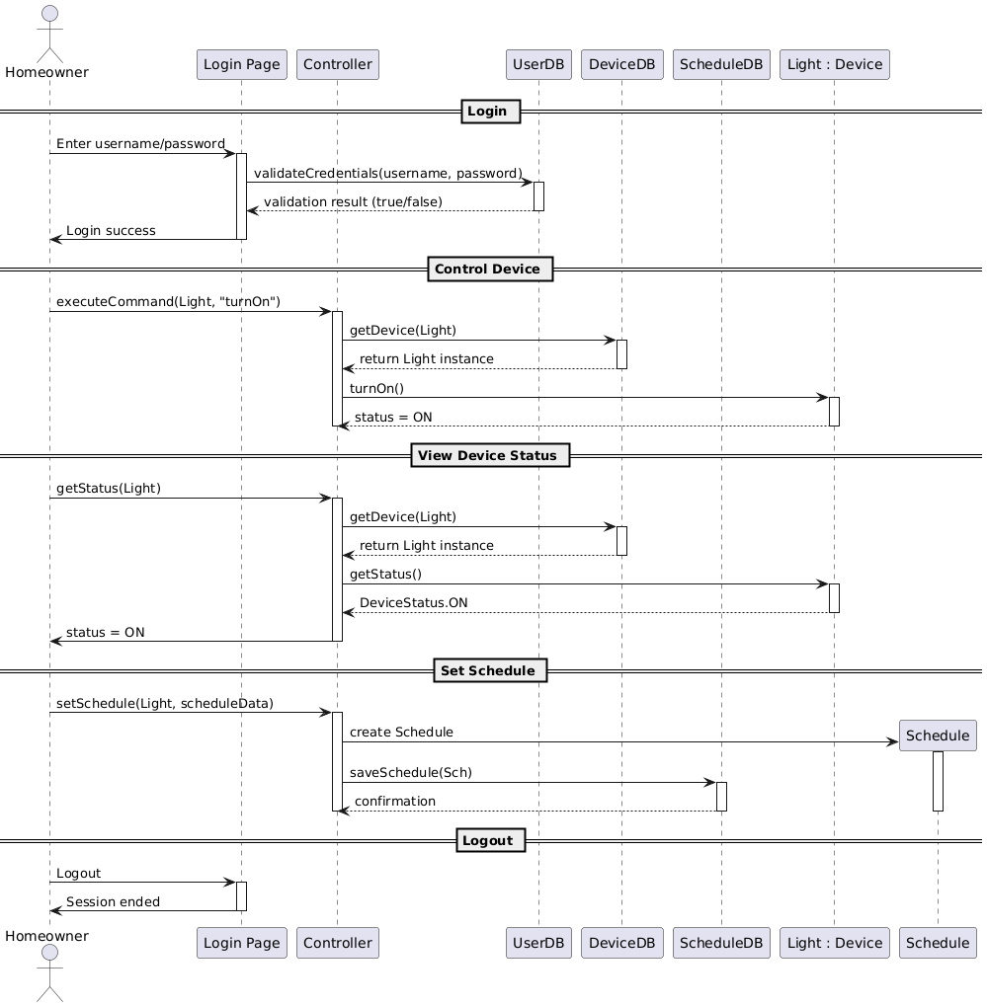

**Low-Fedility Interfaces:**

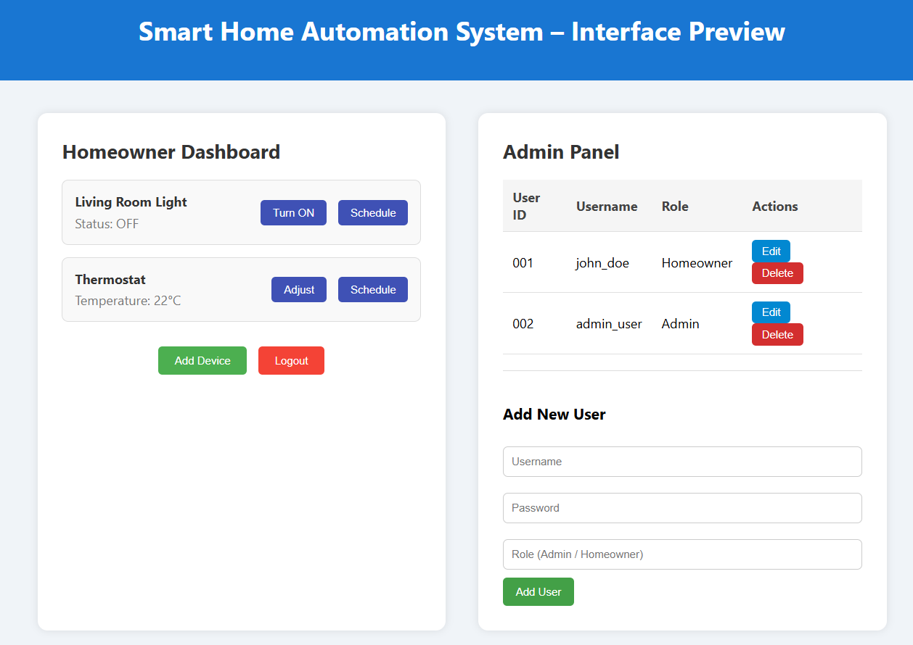

**High-Fedility Interfaces:**

